INTRODUCTION

Chatbots is a program software that allows end-users to interact with computers online via text or speech. Usually, chatbots are accessed online through mobile applications, websites or virtual assistants. Major technologies involved in the development of bots are Artificial Intelligence, Natural Language Processing and Machine learning. AI-enabled bots depend on previous references and are developed to handle complex human queries. While rule-based chatbots follow a sequential path where IVRS is used that is programmed with predefined answers and depends on current information. Some popular examples of chatbots are Adidas women, amazon's ALEXA, WHO's Whatsapp Chatbot, SEPHORA Assistant, Domino's Chatbot, IBM Watson.

Chatbots identify the context of the user and then extracts the relevant data from users’ question. After this, it returns the response to the query in form of a generic text, data from the database, a Piece of information based on what the user has provided as input, the result of the interaction performed by chatbots with other backend applications, error question to re-understand the user’s requirements.

The main objective to implement chatbots was to boost efficiency in terms of operations, reducing costs, offering convenience, added customer services. The first chatbot named ELIZA was created in 1965 which could answer simple decision tree questions. Later, in 1972 chatbot named Parry was created by Kenneth Colby to simulate a person who suffered from paranoid schizophrenia. Then, ALICE was developed by Richard Wallace in 1995 that miserably failed the Turing test. Finally, A developer named Rollo Carpenter was responsible for developing a chatbot in the year 1988.

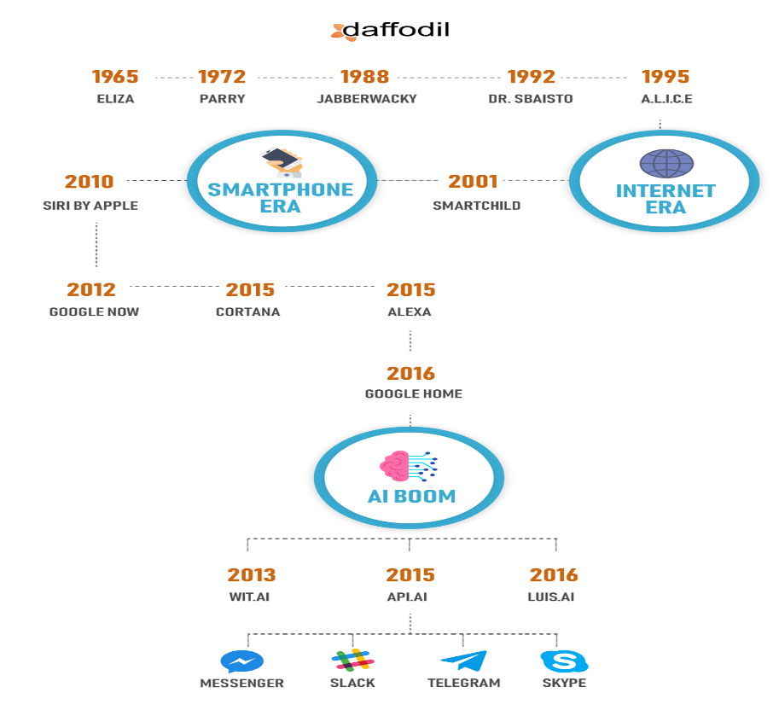

With benefits come limitations. There are lots of issues that people come across while using chatbots. We know, chatbots are machines. At times chatbots might not interpret human context or requirements. The reason is they are rule-based and follow predefined paths. Also, training them requires tonnes of the dataset and hence not every question put forth by the user is understood by a chatbot. Another limitation is that bots require maintenance and up gradation in terms of data or knowledge. The only way to solve this is to provide the bot with as much as possible old as well as new training data. Chatbots lack in taking decisions. The reason is they cannot distinguish between good and bad. For example, Microsoft build for Twitter, the bot was considered racist and rogue because of its incapability to differentiate between good and bad comments. Machines lack emotions. Hence, they are unable to show empathy to the user that might be sad, angry and annoyed. Chatbots are more obvious because they provide the same standard for multiple questions. Even if the question is paraphrased, it provides the same apology that might frustrate users. Bots are programmed. So, if the question asked is not present in the data provided to bots, then they cannot answer.

TYPES OF CHATBOTS

Evolution in chatbots has paved the way for the growth in technology. This growth is a benefit socially and economically. Chatbots are classified into three types according to their technical complexity.

1] Simple Chatbots

Simple chatbots are also known as rule-based bots because they adhere to the constraints or limits that are applied to them. Generally, they possess finite capabilities. They follow IVRS (Interactive voice response system) where the bot presents questions that already have predefined answers and the end-user needs to select an option repetitively until the user won’t get the required answer to the query. This type of chatbot solely depends on its inferences on current questions or information, not on previous interactions. These are easy to build and train and well suited for straightforward conversations.

For instance, while ordering food on any online application like Zomato, flow is predefined. The bot starts by asking the customer to order the food. When asked for the menu, it displays the list and asks the customer to order. Finally, it requests for address and payment method. Customer needs to only click on options to complete the entire process.

2] Smart Chatbots

Smart chatbots are most commonly known as AI-enabled bots. These are designed to automate the routine tasks that humans perform. They are intelligent enough to understand the language, emotion, intent that the user wants to convey. Conversations here are free-flowing. They are programmed in a way that they can adapt to situations that they are not aware of. Training them might require tonnes of data. Hence, it is difficult to implement them.

Smart chatbots like Siri, Cortona, Alexa and many more are trendy because of their existing features also termed as virtual assistants. Virtual assistants don’t follow commands already programmed but learns from human interaction. From playing music to having a small conversation with a person, chatbots more or less have gained more popularity.

3] Hybrid Chatbots

As the name suggests, hybrid chatbots are the integration of simple and smart chatbots. Looking at situations today, both the bots are equally important. They follow rules but can interpret the context the user wants to put forth. It is the perfect balanced tool that can be widely used in businesses.

An application where hybrid chatbots are used is a medical diagnosis. Visitors convey their health issues over a voice chat. This is a more efficient way to note down the symptoms rather than using the rule-based format. In this way, the patient can describe the issues in depth so that prescribing medicine for that particular disease might become easy because of the detailed information.

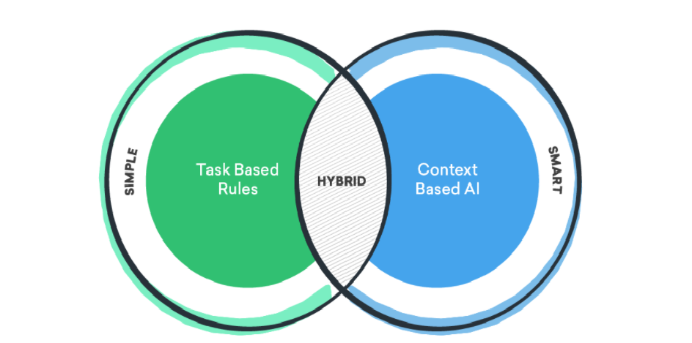

CONCLUSION

To conclude, every aspect has advantages and disadvantages. Also, these issues cannot be avoided because of their connection with business and might be an obstacle in the growth of the company and revenue generation. Regardless of this fact, organizations are still investing in chatbots. A survey asserts that 55% and more clients are attracted to chatbot abilities because of their availability 24\*7. We can say those virtual assistants and smart bots if ameliorated they can change the direction of the world. Apart from social media, they are being introduced in critical sectors like banking, healthcare, e-commerce. Moreover, chatbots are a promising tool for collecting necessary data that can be helpful in future.